Garage Management System

Project Overview:

The Garage Management System in Salesforce is designed to automate and streamline daily garage operations, including customer bookings, vehicle service tracking, spare parts inventory, and billing. Traditional garage operations often rely on manual registers or standalone applications, which lead to inefficiencies, missed appointments, and poor customer experiences.

By using Salesforce CRM, this system integrates customer, vehicle, service, and billing data into a single platform. It enables garage owners and employees to track service history, send automated reminders, manage spare parts, and generate real-time performance reports.

This project ensures better customer satisfaction, efficient garage management, and scalability for future business needs.

**Objectives**

The key objectives of the Garage Management System in Salesforce are:

1. Automate vehicle service booking, job card creation, and status tracking.
2. Maintain a centralized database of customers, vehicles, service records, and payments.
3. Implement automated reminders for service due dates, delivery readiness, and billing.
4. Provide dashboards and reports on garage revenue, popular services, and employee performance.
5. Manage spare parts inventory with automated low-stock alerts.
6. Ensure role-based security for admins, mechanics, and customers.
7. Minimize manual errors through Salesforce validation rules and automation tools.

8 . Ensure scalability for future integration with mobile apps, IoT devices, or AI

service predictions.

**Phase 1: Requirement Analysis & Planning**

Requirement gathering focuses on understanding the needs of garage owners, mechanics, and customers.

**Key Activities:**

* Business Requirement Study: Identify gaps in existing garage workflows.
* Scope Definition: Service booking, vehicle tracking, billing, inventory management.
* Data Model Planning: Objects such as *Customer, Vehicle, Service Request, Spare Part, Payment*.
* Security Planning: Role hierarchy (Admin → Service Manager → Mechanic → Customer).
* Timeline Planning: Dividing project into analysis, development, testing, and deployment phases.

Objects created for the project

APPOINTMENT

SERVICE RECORDS

CUSTOMER DETAILS

BILLING DETAILS AND FEEDBACK

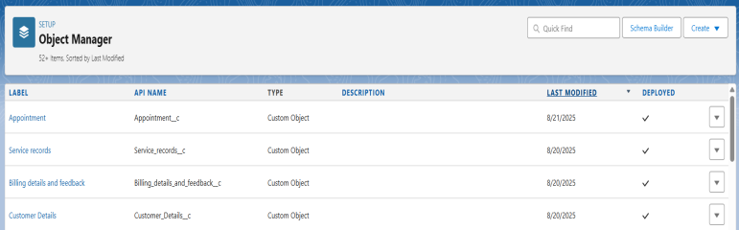

FIELD AND RELATIONSHIPS OF SERVICE RECORDS.

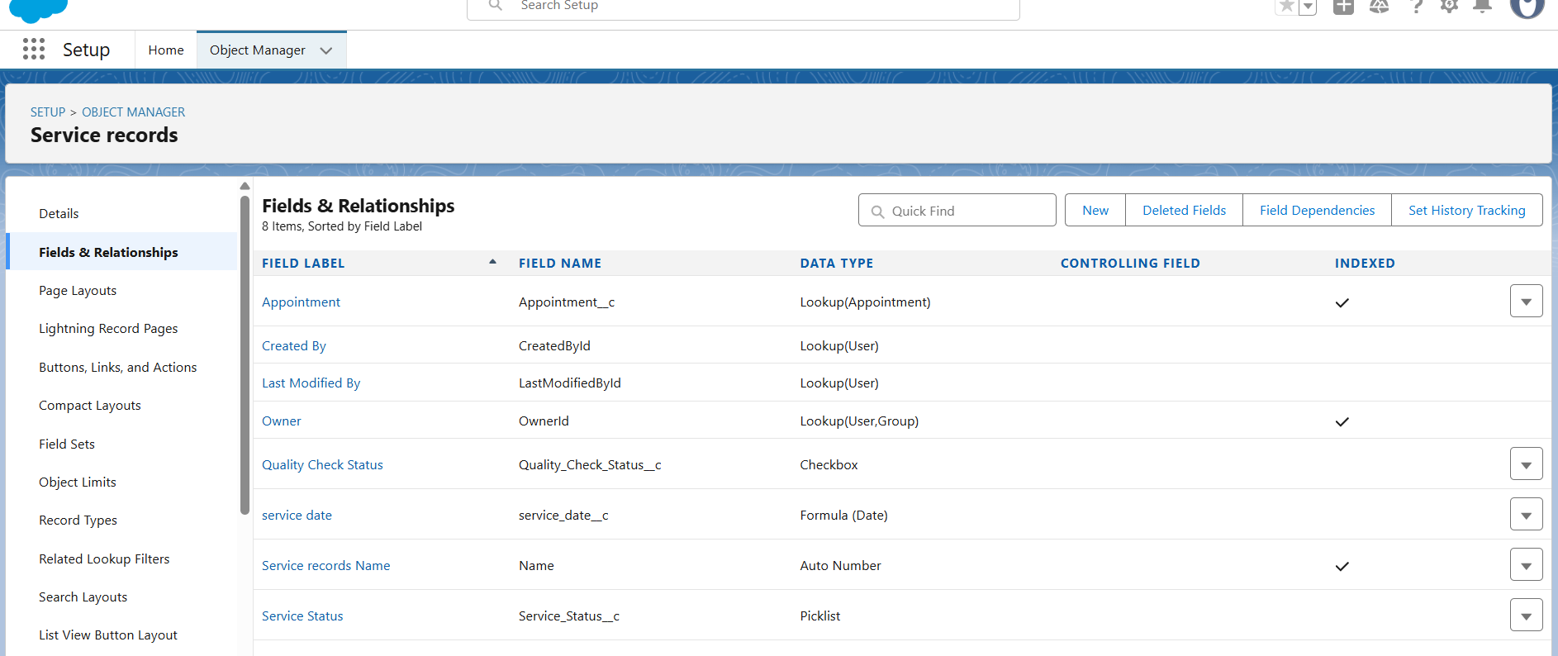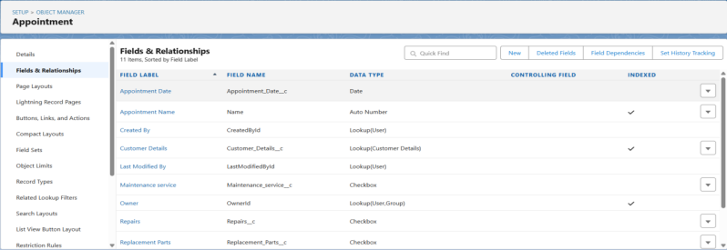

FIELD AND RELATIONSHIPS FOR APPOINTMENT OBJECT

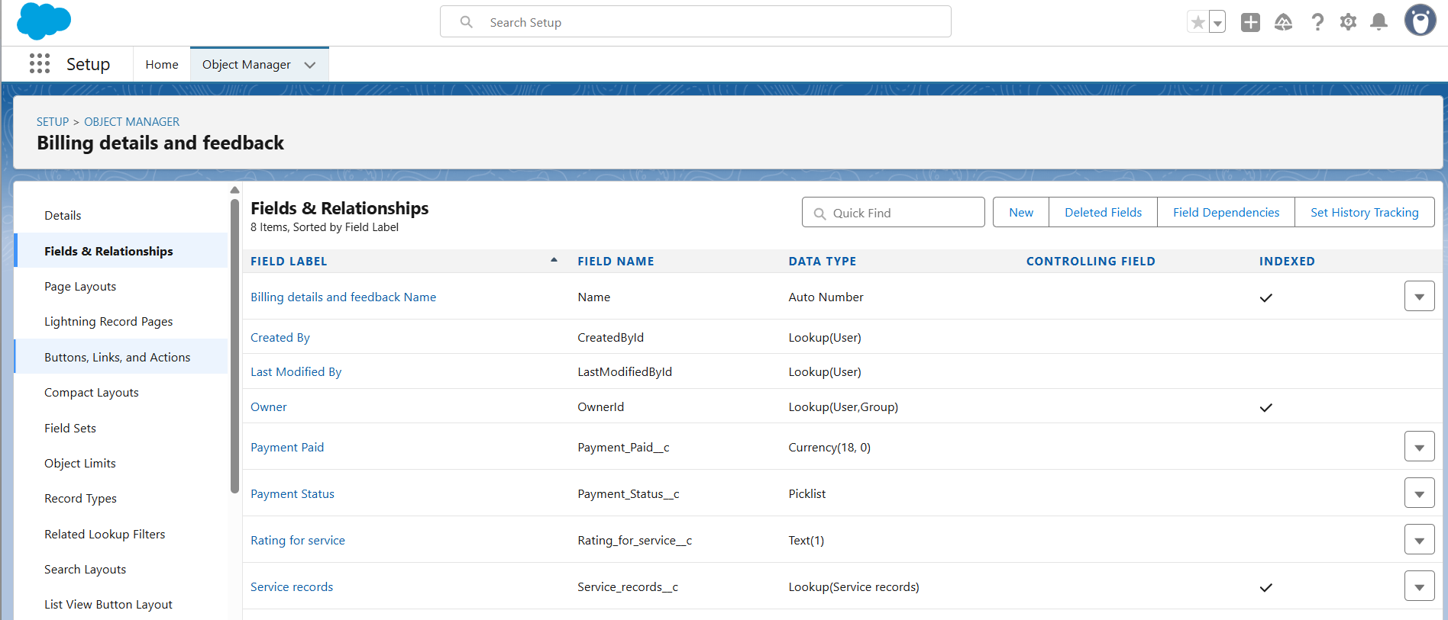

FIELD AND RELATIONSHIPS FOR BILLING DETAILS AND FEEDBACK

Roles assigned for the system

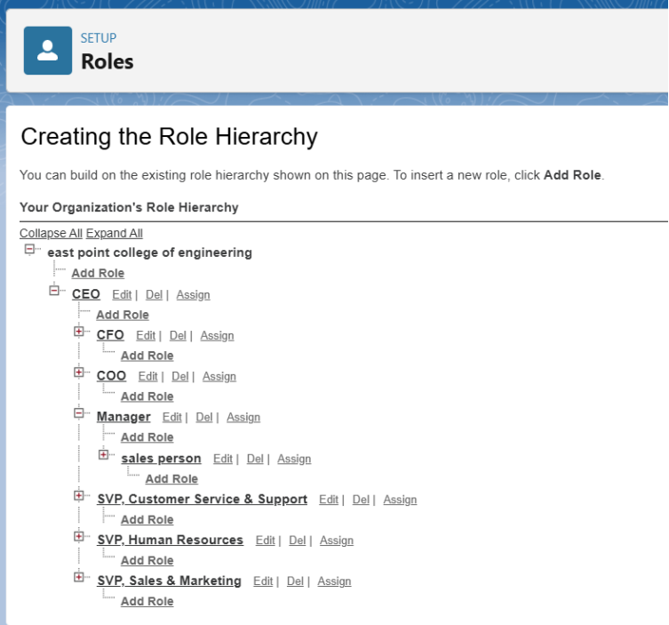

**Phase 2: Salesforce Development – Backend & Configurations**

This phase involves setting up Salesforce to reflect garage processes.

**Key Activities:**

* **Custom Objects:** Customer, Vehicle, Service Request, Job Card, Spare Part, Payment.
* **Validation Rules:** Service completion date must be ≥ start date, stock quantity cannot be negative.
* **Workflow Rules & Flows:** Service due reminders, inventory stock alerts, billing notifications.
* **Apex Triggers:** Automatic update of service status, auto-generation of invoice numbers.
* **Page Layouts:** Different views for mechanics, service managers, and customers.

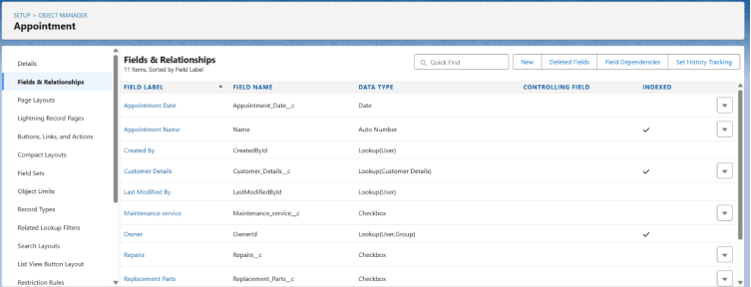

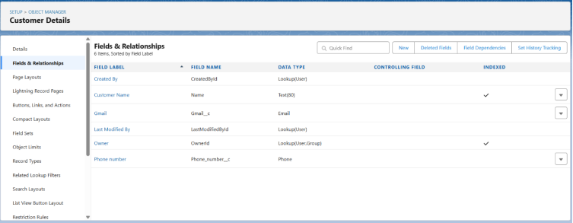

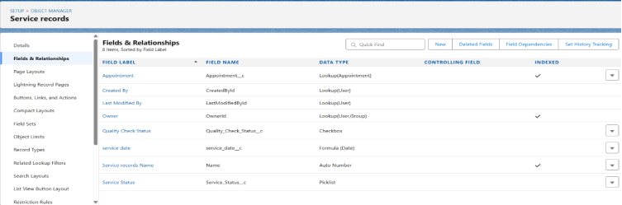

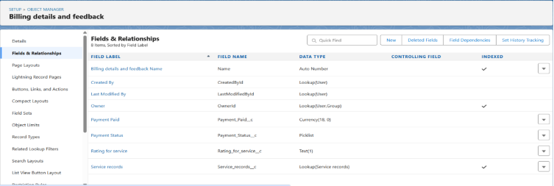

**Phase 3: UI/UX Development & Customization**

The front-end must be simple and user-friendly for mechanics and managers.

**Key Activities:**

* Lightning Pages for Service Requests, Job Cards, and Vehicle records.
* Dynamic Forms to show fields relevant to the type of service (e.g., maintenance, repair, inspection).
* Reports & Dashboards for service trends, customer satisfaction, and revenue tracking.
* Lightning Web Components (optional) for service booking portals or spare part lookup.

Lightning app of Garage management System

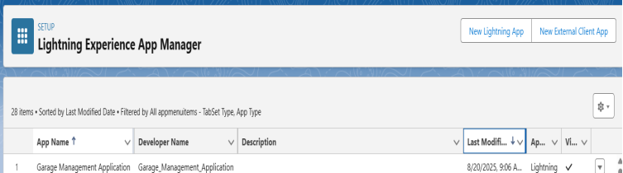

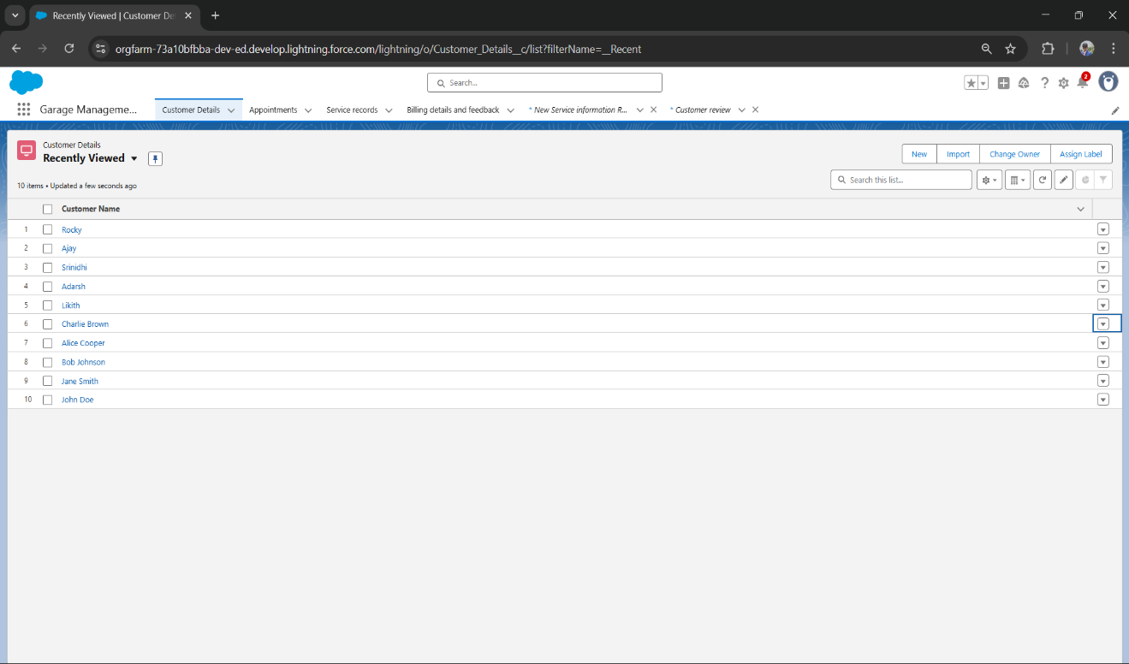

Tab view of lightning app

**Phase 4: Data Migration, Testing & Security**

Migrating existing garage records and ensuring reliability.

**Key Activities:**

* Import legacy data (customer history, vehicles, spare parts) via Data Loader.
* Testing: Unit testing (service creation), Integration testing (billing + inventory), UAT for managers.
* Security Model: Mechanics have limited access, managers have approval rights, customers can view status.

Compliance: Password protection, audit trails, field history tracking for critical records.

**Phase 5: Deployment, Documentation & Maintenance**

This phase ensures the Garage Management System is production-ready.

**Key Activities:**

* Deployment through Change Sets or Salesforce CLI.
* Documentation: User guide for mechanics and admin guide for managers.
* Maintenance: System monitoring, bug fixes, spare part updates, and service template changes.
* Scalability: Adding AI-based service prediction, mobile apps for booking, IoT sensors for vehicle health.

Customer review tab

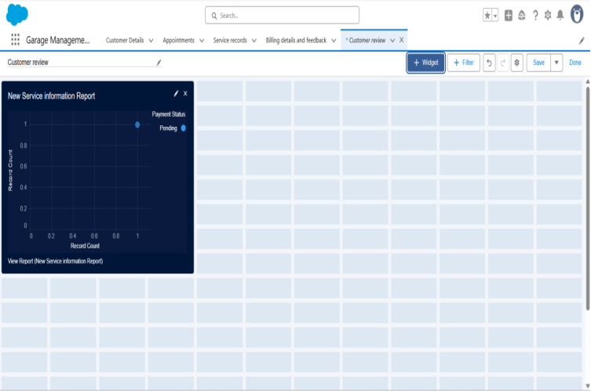

Customer details tab of garage management app

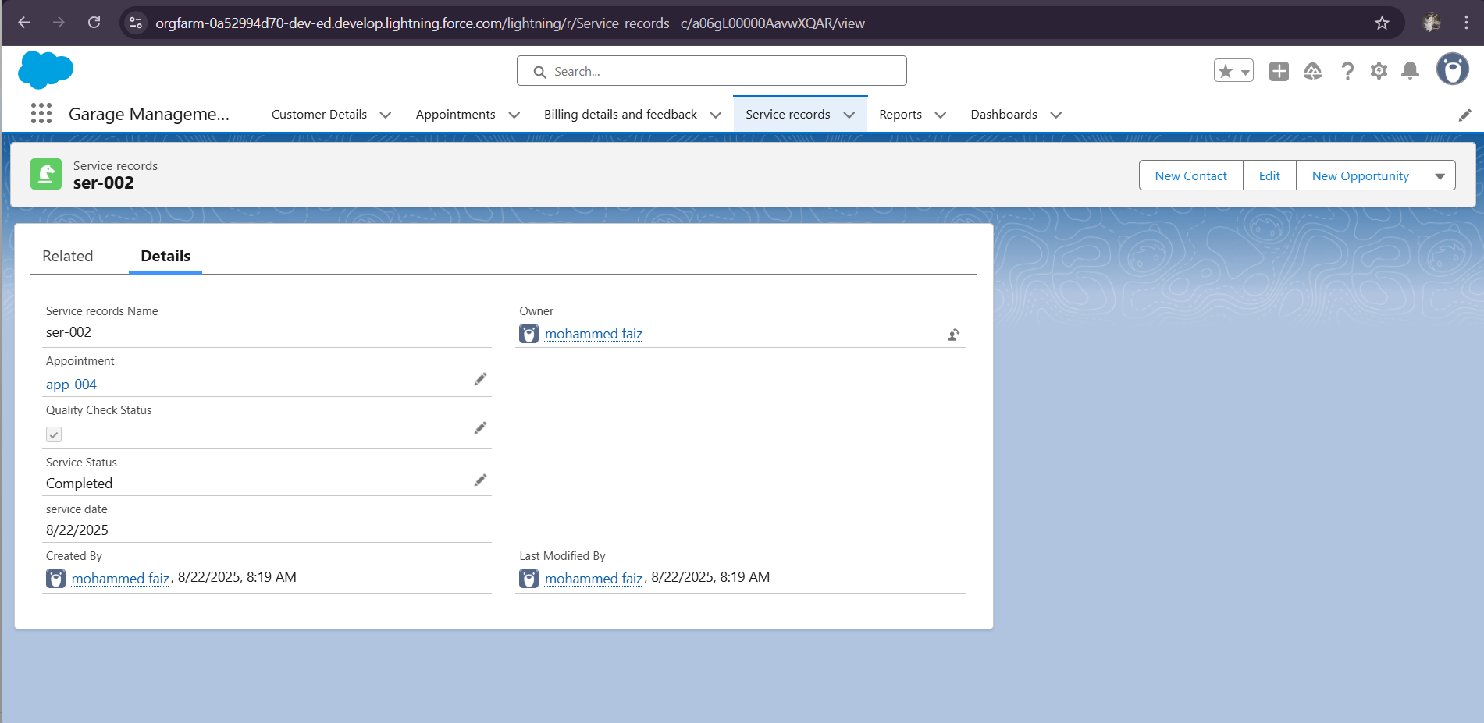

**Conclusion**

The Garage Management System in Salesforce provides a complete end-to-end digitaL Platform for managing vehicles, customers, services, inventory, and billing. It improves efficiency by automating manual tasks, enhances customer satisfaction through timely reminders, and provides data-driven insights to garage owners.

Future enhancements can include integration with IoT-based vehicle monitoring, AI-based service recommendations, and customer-facing mobile apps for seamless booking and tracking.